[Group 72] LearnLoop - A Stateful Agentic Platform for Adaptive Learning

Group Members
Name | Student ID | Email
Fong Chi Ching | 3035299466 | u3529946@connect.hku.hk
Ching Nok Yee | 3035283572 | u3528357@connect.hku.hk
Lai Hok Lam Justin | 3036657081 | u3665708@connect.hku.hk
Zhou Yuxin | 3036791693 | u3679169@connect.hku.hk

2. Project Objective
This project aims to build LearnLoop, an agentic learning platform that turns a student's uploaded course materials into an adaptive, persistent learning journey. Given a set of documents and a learner-defined goal, LearnLoop decides what the learner should do next and whether they have understood it, revising the plan as evidence accumulates across sessions. The deliverable is a working end-to-end system, not a model or a single prompt.
We pursue three objectives:
- Decide the next best action. A source-grounded agent–environment loop, informed by ReAct [1], proposes an educational action, the runtime validates and executes it, and the observation informs the next decision.
- Ground decisions in course content. LearnLoop derives learning items and prerequisites from the uploaded materials, scaling depth to each document's length and structure, and maintains topic and learner state through reusable mission templates.
- Verify and track progress. Actions are validated before execution, and learner state updates only on rubric-meeting evidence, so the system distinguishes lasting misunderstandings from temporary mistakes and resumes interrupted sessions.
To evaluate, we will use 40 held-out multi-step scenarios, each run three times per system. We compare LearnLoop against a fixed-sequence tutor and a tutor without cross-session memory, measuring adaptive decision quality, assessment quality, state reliability, workflow robustness, and latency and cost (Section 5).

3. Motivation and Challenges
Students often receive course outlines, slides, and readings but are unsure where to start, which ideas matter most, or what they need to understand first. They may review familiar topics while overlooking gaps in their knowledge. Asking a chatbot to explain a topic is possible, but the quality depends heavily on how the question is phrased. It is also hard to keep track of their own progress.
LearnLoop addresses this by organizing uploaded materials into a learning path, checking what students understand, and offering practice or explanations where needed. By remembering earlier attempts, it revisits difficult topics and adjusts the plan over time. Research on intelligent tutoring systems supports this approach [2]. We will evaluate whether LearnLoop selects useful activities and helps students navigate their materials more confidently.
The main challenges are recognizing a lasting misunderstanding rather than a temporary mistake, finding reliable support in the uploaded materials, and keeping an accurate record of progress. We will check assessment evidence before updating the learner's state, allow the system to express uncertainty, and limit repeated attempts when tools fail. Missions and rewards will support the learning tasks, while progress will depend on demonstrated understanding. We will assess learning and motivation separately, as suggested by research on gamification [3].

4. Potential Solutions

4.1 Knowledge Graph and Specialized Agents
LearnLoop will coordinate an Expert Agent, a Tutoring Agent, and an Assessing Agent through a shared runtime. The Expert Agent will convert COMP7608B materials into a knowledge graph of concepts and prerequisite, dependency, and related-topic relationships. It will generate explanations, worked examples, questions, progressive hints, reference answers, and rubrics at basic (recall), intermediate (application), and advanced (analysis) levels. Retrieval will supply supporting course passages, drawing on retrieval-augmented generation [4]. Each resource and graph relationship will retain source references; optional external enrichment will be separated from assessed course content.
The Tutoring Agent will filter concepts by prerequisite readiness, then rank activities using learner need, assessment uncertainty, review urgency, and recent performance. It may introduce a concept, provide practice, change difficulty, revisit a prerequisite, schedule review, or advance. The Assessing Agent will evaluate rubric coverage and correctness as primary evidence, with difficulty, hint usage, response time, prior attempts, and contradictions informing confidence. It will identify misconceptions and propose updates for runtime validation.

4.2 Difficulty Aware Learner Model
Each learner will have a persistent overlay on the shared graph, inspired by knowledge tracing [5]. For each concept, the system will retain evidence at all three difficulty levels, including independent and hinted attempts, misconceptions, contradictory evidence, assessment dates, and review schedules. Overall status will reflect the concept’s target difficulty: unassessed (insufficient evidence), developing (partial or supported understanding), demonstrated (sufficient independent evidence), or review_due (reassessment needed). Thus, basic success will not imply advanced understanding.
For the prototype, demonstrated status will require repeated rubric-meeting responses at the target difficulty, without hints or unresolved contradictions. Later errors will preserve prior evidence while triggering diagnosis, review, or a return to developing. These are explicit prototype rules, rather than a claim to implement the probabilistic model in [5].

4.3 Autonomous Loop and Runtime Control
The workflow will repeatedly observe learner state and course evidence, select an instructional action, execute an authorized tool, assess the response, and verify the resulting update. Following ReAct [1], each new observation will inform the next decision. Assessment feedback and retained summaries will support subsequent adaptation, drawing on feedback-based agent memory [6]. The system will pause for learner input or stop when goals or execution limits are reached.
The runtime will enforce typed tool contracts, valid source and record identifiers, prerequisite constraints, and permitted state transitions. Version checks and unique operation IDs will prevent stale or duplicate writes; durable checkpoints will support session resumption. Bounded retries and explicit insufficient-evidence outcomes will control failures. Traces will record decisions, tool outcomes, evidence, proposed and committed updates, latency, tokens, and cost for multi-step trajectory evaluation [7]. Appendix A provides tool contracts and acceptance cases.

5 Experimental Dataset Description and Evaluation Plan

5.1 Course Dataset and Learning Resources
The initial dataset will consist of selected COMP7608B course materials. To maintain a feasible scope, the prototype will focus on one coherent course unit containing approximately 10 to 20 concepts and their relationships. The Expert Agent will use these materials to generate:
- a source-grounded knowledge graph;
- concept descriptions and learning objectives;
- explanations and worked examples;
- questions at three difficulty levels;
- progressive hints;
- reference answers and assessment rubrics.
Generated nodes, edges, questions, and rubrics will retain links to the supporting course passages. The group will manually review a sample of the generated resources for conceptual correctness, source grounding, prerequisite accuracy, and appropriate difficulty. Test questions used for final evaluation will be excluded from the agents’ retrieval and teaching resources.

5.2 Prompt Configurations
We will prepare three prompt variants for each agent, creating a 3×3×3 factorial design with 27 configurations.
- Expert Agent prompts will vary in their use of structural guidance, source-grounding requirements, and output verification.
- Tutoring Agent prompts will vary between state-based, graph-aware, and utility-based activity selection.
- Assessing Agent prompts will vary between correctness-focused, evidence-weighted, and conservative state assessment.
The model versions, agent tools, structured output schemas, knowledge graph, activity budget, and factual course information will remain fixed. The experiment will therefore evaluate differences in prompting strategy rather than differences in available information or system capability.

5.3 Measures and Review Protocol
Each configuration will interact with the same controlled LLM-based pseudo-students. Rather than using an unrestricted model to imitate a generic student, each pseudo-student will be assigned a hidden profile containing:
- initial knowledge and concept states;
- difficulty-specific ability;
- selected misconceptions;
- hint dependence;
- response characteristics;
- persistent memory of previous teaching.
Profiles may represent novice, intermediate, misconception-prone, and hint-dependent learners. The same profiles, initial states, activity limits, and stopping conditions will be used across all 27 configurations.
The pseudo-student’s hidden state will be maintained separately from LearnLoop’s estimated learner model. This separation will allow us to compare the Assessing Agent’s updates with the simulator’s underlying knowledge and measure whether the system reaches accurate learner-state conclusions. Multiple runs will be conducted for each configuration to reduce the influence of stochastic model outputs.

5.4 Evaluation Measures
We will evaluate each configuration across four dimensions.
Measure | Definition or assessment
Learning quality | Performance on an unseen post-test, concepts mastered, learning gain per activity, and activities required to reach the target performance
Learner-state accuracy | Agreement between LearnLoop’s estimated states and the pseudo-student’s hidden states, including macro F1, difficulty estimation, misconception detection, and false-demonstration rate
Trajectory quality | Appropriateness of concept selection, prerequisite consistency, difficulty suitability, evidence use, state-update validity, redundancy, and recovery from uncertainty
Operational performance | Input and output tokens, monetary cost, cost per mastered concept, end-to-end latency, and median and p95 latency by agent
A fixed, unseen post-test will be administered after each learning episode. The post-test will contain questions at multiple difficulty levels and will be evaluated independently of the experimental Assessing Agent. This prevents an overly lenient assessor from appearing successful by assigning demonstrated prematurely.
Structured traces will record the learner evidence available to each agent, candidate and selected actions, tool calls, concept and difficulty choices, proposed and committed state changes, errors, retries, token consumption, latency, and cost. Trajectories will be reviewed using a common rubric, while deterministic checks will identify prerequisite violations, invalid transitions, repeated actions, and unsupported mastery updates.

5.5 Experimental Controls and Analysis
All 27 configurations will use the same:
- COMP7608B knowledge graph and learning resources;
- pseudo-student profiles and initial states;
- model versions and generation settings;
- question and activity pools;
- maximum number of learning turns;
- final post-test and scoring criteria;
- tool permissions and runtime limits.
The analysis will examine the individual effects of the Expert, Tutoring, and Assessing Agent prompts, as well as interactions among them. Configurations will be compared according to learning quality, learner-state accuracy, trajectory quality, latency, and cost. We will also identify configurations on the quality-efficiency frontier, rather than assuming that the configuration with the highest token consumption or longest trajectory is necessarily the best.
If evaluating every configuration through repeated full-length episodes becomes prohibitively expensive, a two-stage evaluation will be used. All 27 configurations will first undergo a shorter screening experiment. The strongest non-dominated configurations will then receive repeated full-length evaluation and detailed trajectory review.

Appendix A Tool Contracts and Verification Cases
The following planned interfaces make the model–runtime boundary explicit. Every result will include status and evidence or a structured error. Identifiers must refer to authorized course, learner, or activity records.

A1 Learning Cycle
Stage | LearnLoop behavior
Observe | Load the learning goal, current response, relevant history, and available course evidence.
Decide | Select diagnosis, prerequisite review, explanation, practice, advancement, or a request for clarification. Return a typed proposal with objective and evidence IDs.
Execute | Validate the proposal, authorize the operation, and dispatch a permitted tool that retrieves evidence, assigns an activity, or revises the plan.
Verify | Check tool outcomes, source support, and update preconditions; commit validated changes and retain the observation.
Continue or stop | Rebuild context after an observation; pause for the learner, finish the cycle, or report a blocked action when evidence or execution budgets are exhausted.

A2 Tool Contracts
Tool | Input contract | Result and runtime checks
retrieve_evidence | course_id, concept_id, query | Source passages and page IDs; course scope and retrieval limits enforced. Empty results preserve the evidence gap.
load_learner_state | learner_id, concept_ids | Current records and versions; ownership checked before selected records enter context.
assess_response | activity_id, response, hint_used | Rubric score, evidence IDs, misconception candidates, uncertainty; activity and source references validated.
assign_activity | operation_id, objective_id, activity_type, evidence_ids | Persisted activity ID and status; supported objective, template and evidence required. Duplicate operation IDs return the original outcome.
revise_plan | operation_id, expected_version, activity_ids, review_dates | New plan version; learner ownership, prerequisite constraints and prior commit checked transactionally.
record_assessment | operation_id, expected_version, assessment_id, candidate_update | Committed evidence and concept status; transition preconditions enforced. The model cannot directly overwrite mastery.

A3 Executable Acceptance Cases
Hint‑dependent success: a correct hinted answer is recorded but cannot independently support demonstrated status. Contradictory evidence: a later wrong answer preserves the earlier record and requests diagnosis rather than silently discarding it. Missing evidence: retrieval returns no suitable source and the cycle reports insufficient support. Resume: an answer to a pending question restores the activity and counters from a durable checkpoint. Retry safety: a timed‑out plan write that already committed returns its original result after restart, with no duplicate activity. Budget exhaustion: the runtime stops and retains a progress record instead of continuing indefinitely.

A4 Limits of the Initial Study
A reviewed concept graph reduces extraction risk but does not test autonomous curriculum discovery. Authored trajectories provide controlled coverage but simplify real learner behavior. Source‑grounded LLM assessment can still misgrade responses; persistent errors and uncertain cases will therefore be reported explicitly. Gamification is a supporting interface feature whose educational benefit remains an exploratory question.

Appendix B Agent Design Figures
Figures 2–4 show each agent’s tools, decision branches and handoffs. Agents propose actions and evidence; the shared runtime validates tool execution and commits permitted state changes. Retries remain within the cycle’s execution limits.
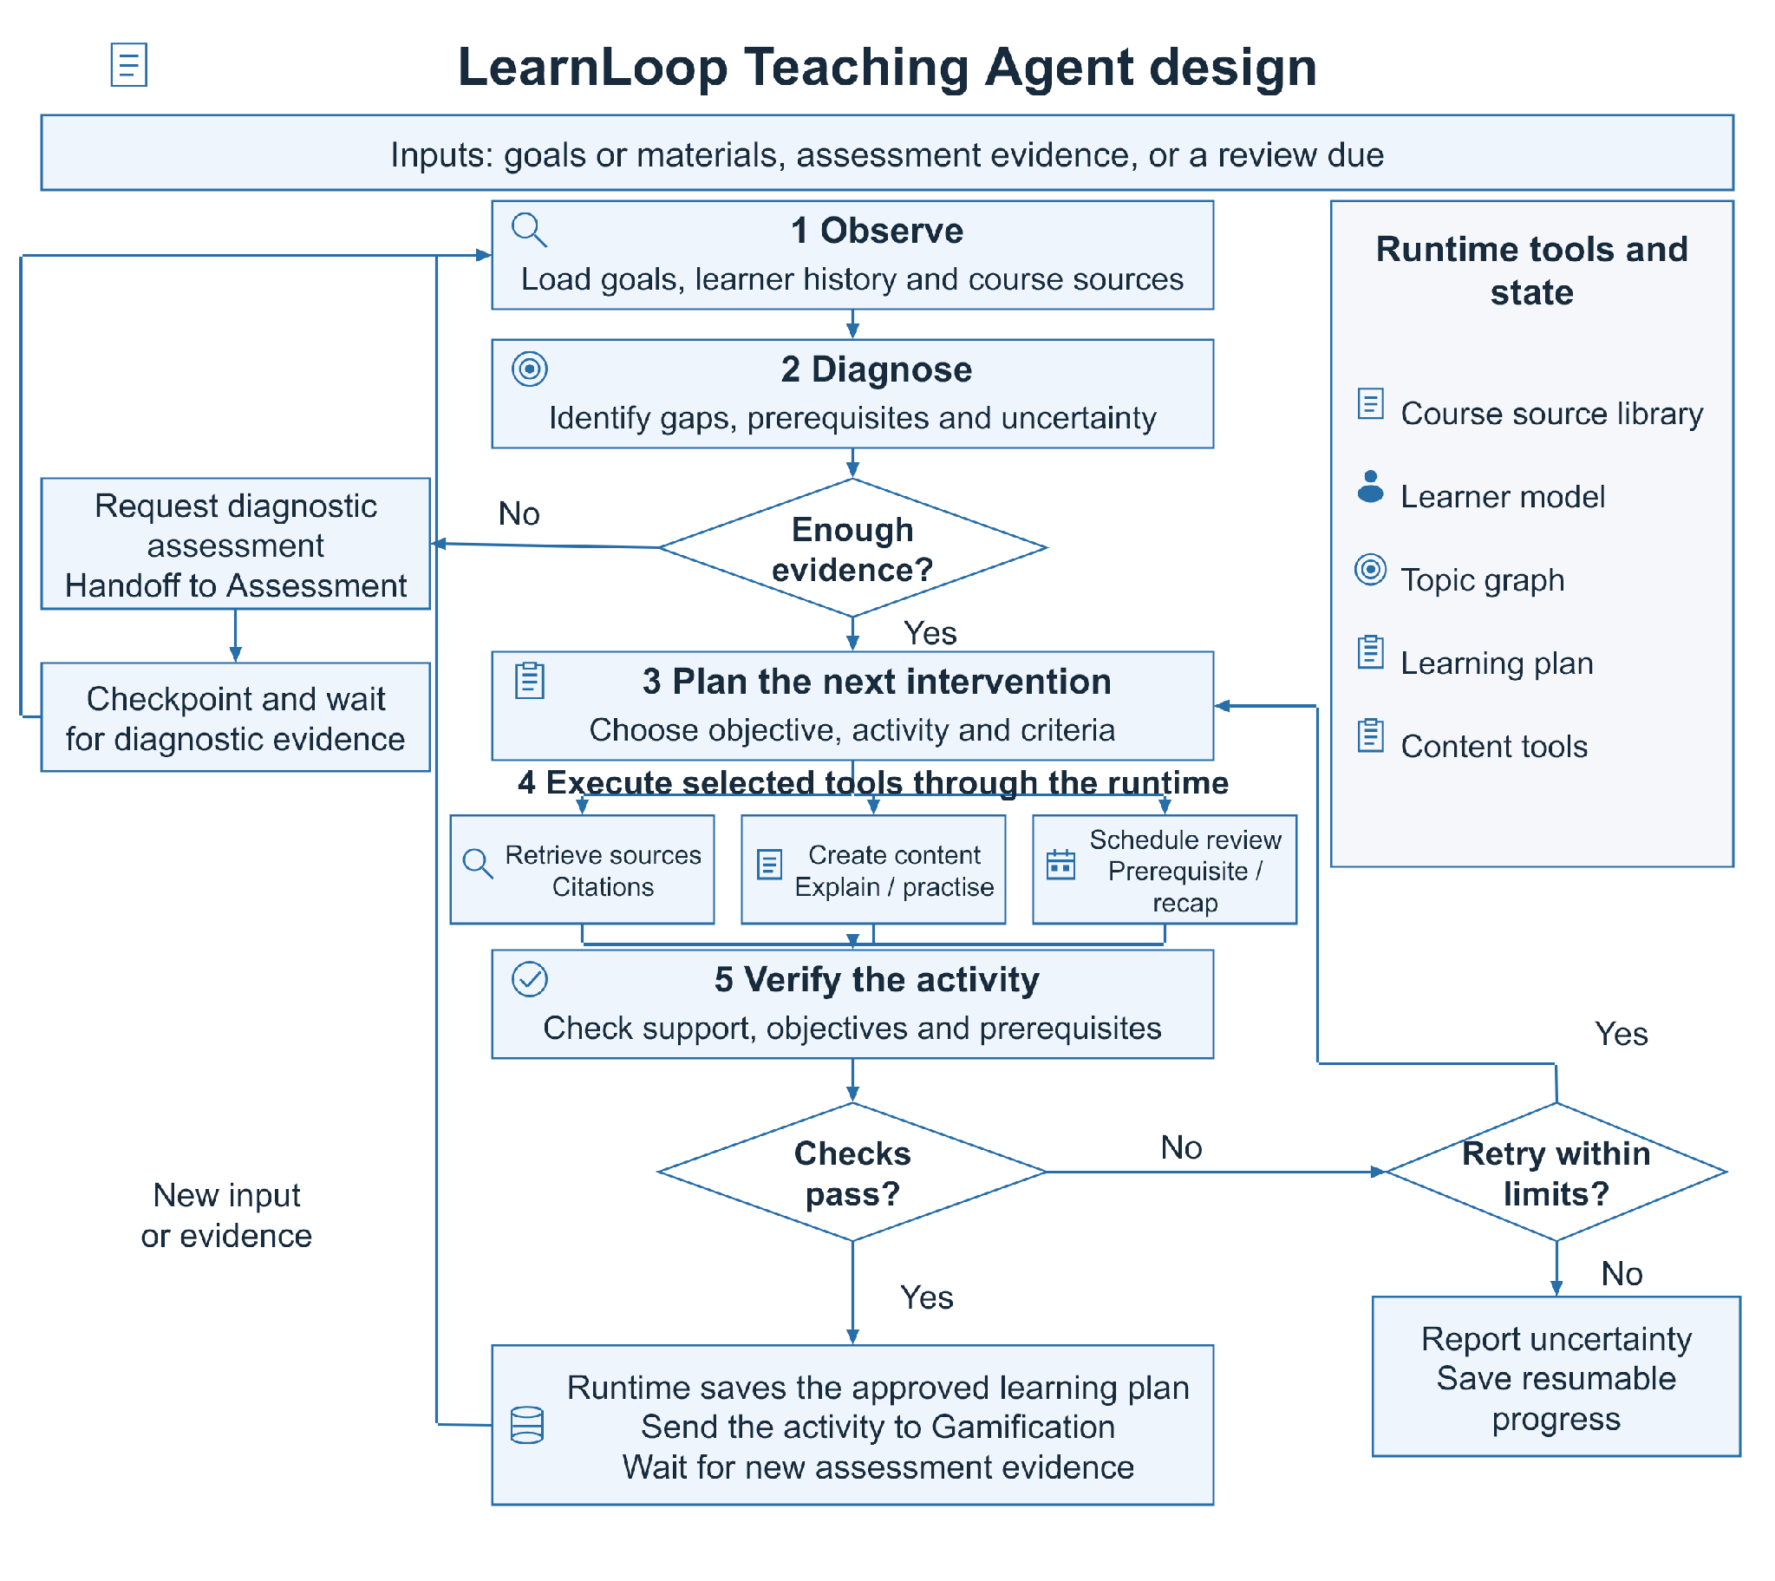
Figure 2 Teaching Agent design. Diagnostic evidence guides intervention selection; the runtime saves the verified plan and hands approved activities to Gamification.
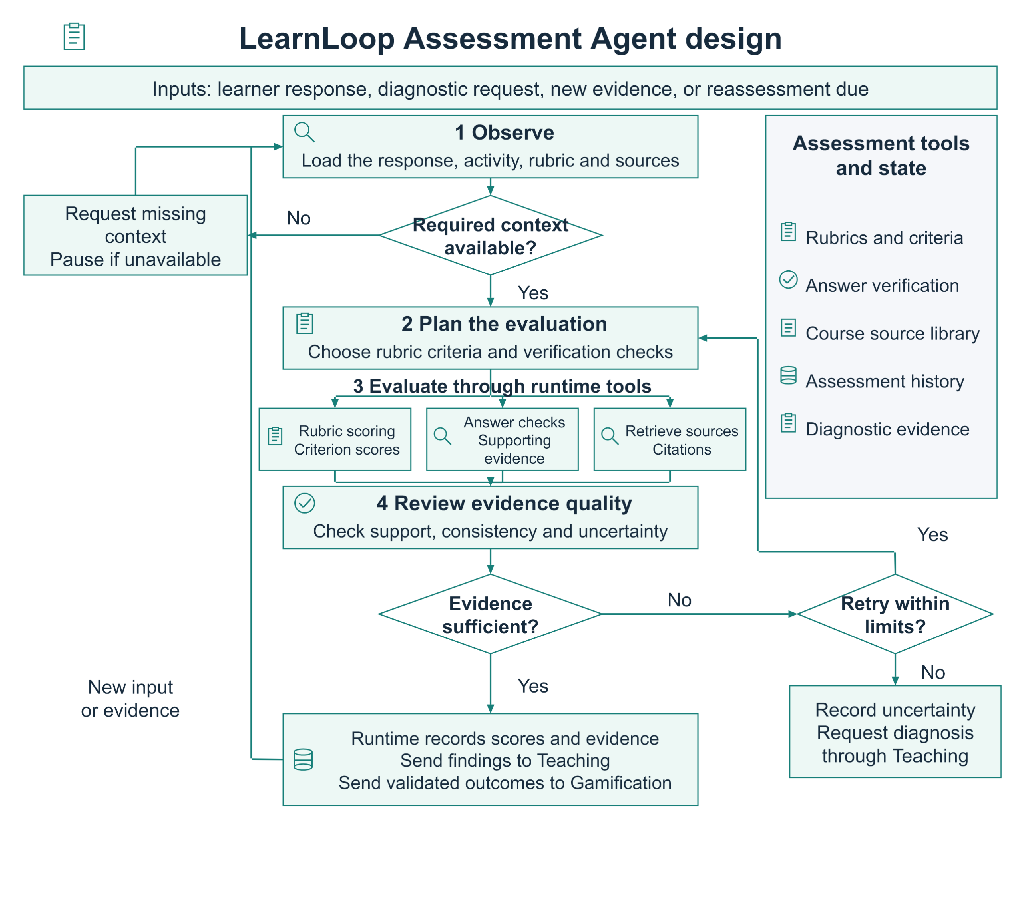
Figure 3 Assessment Agent design. Rubric scores, answer checks and source evidence inform teaching decisions. Insufficient evidence triggers bounded checks or further diagnosis.
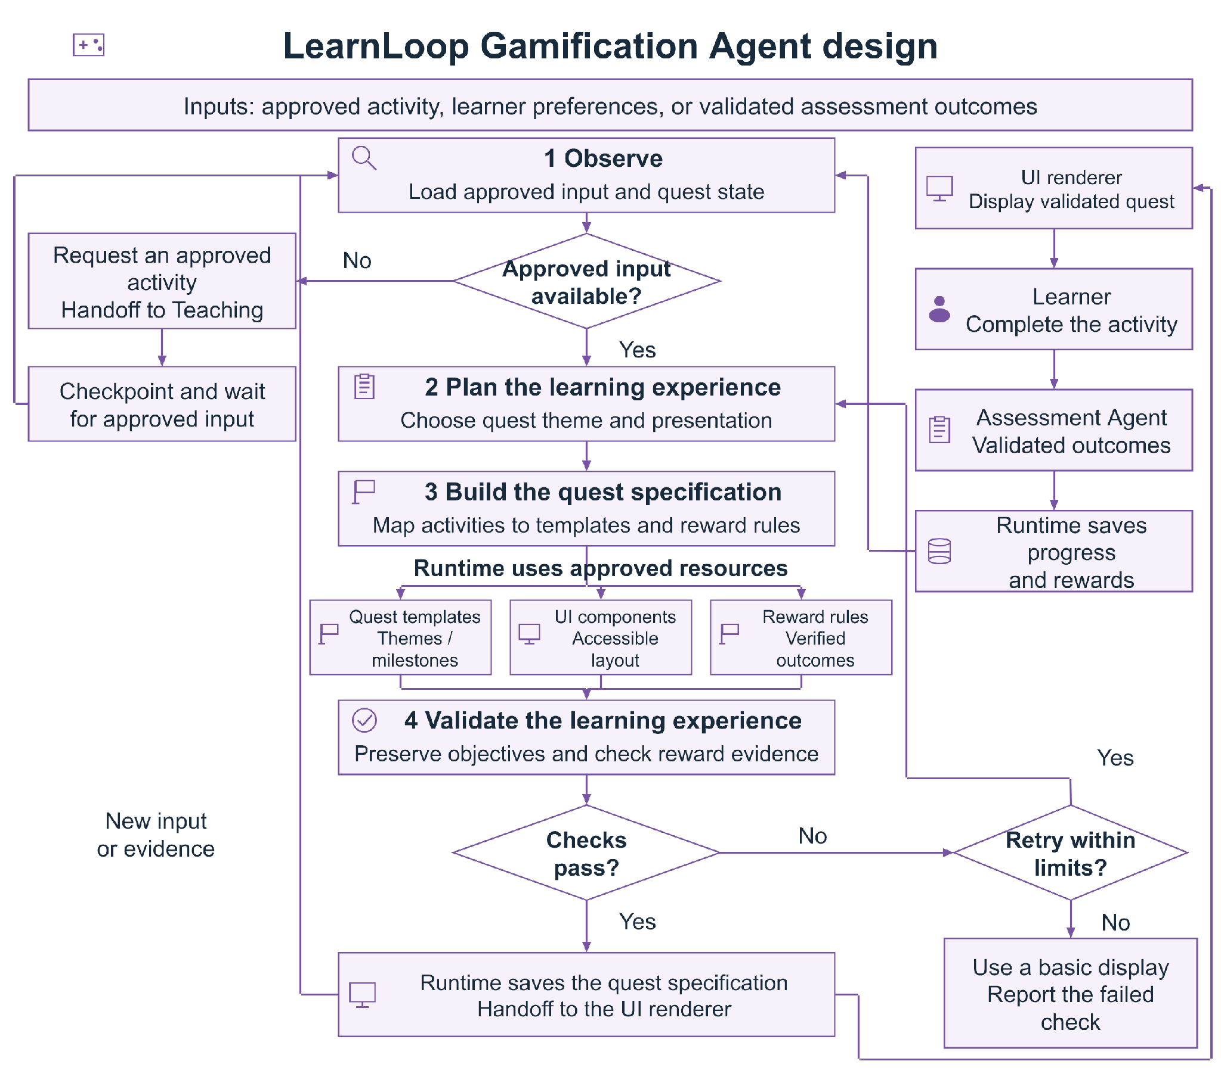
Figure 4 Gamification Agent design. Approved templates preserve learning objectives. The runtime records progress and rewards after validated assessment outcomes.

References
[1] Yao, S., Zhao, J., Yu, D., Du, N., Shafran, I., Narasimhan, K., and Cao, Y. (2023). ReAct: Synergizing Reasoning and Acting in Language Models. International Conference on Learning Representations (ICLR). Source
[2] Ma, W., Adesope, O. O., Nesbit, J. C., and Liu, Q. (2014). Intelligent tutoring systems and learning outcomes: A meta‑analysis. Journal of Educational Psychology, 106(4), 901–918. Source
[3] Sailer, M., and Homner, L. (2020). The Gamification of Learning: A Meta‑analysis. Educational Psychology Review, 32, 77–112. Source
[4] Lewis, P., et al. (2020). Retrieval‑Augmented Generation for Knowledge‑Intensive NLP Tasks. Advances in Neural Information Processing Systems, 33, 9459–9474. Source
[5] Corbett, A. T., and Anderson, J. R. (1994). Knowledge tracing: Modeling the acquisition of procedural knowledge. User Modeling and User‑Adapted Interaction, 4, 253–278. Source
[6] Shinn, N., Cassano, F., Gopinath, A., Narasimhan, K., and Yao, S. (2023). Reflexion: Language Agents with Verbal Reinforcement Learning. Advances in Neural Information Processing Systems, 36. Source
[7] Liu, X., et al. (2024). AgentBench: Evaluating LLMs as Agents. International Conference on Learning Representations (ICLR). Source

